Answer 9
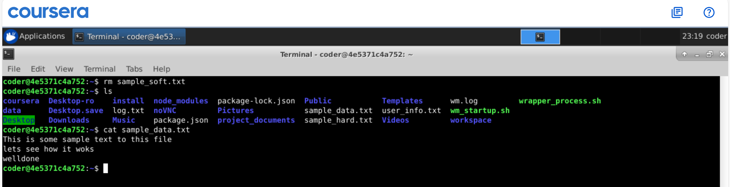
Explanation: By using rm command we can remove the file by removing soft link we have no changes to the original file as seen. We could also unlink the soft link and it will still won’t affect the original file. Though link will be dangling without source.

